To load file in Excel with uft-8 encoding:

1. Open Excel with blank workbook
2. 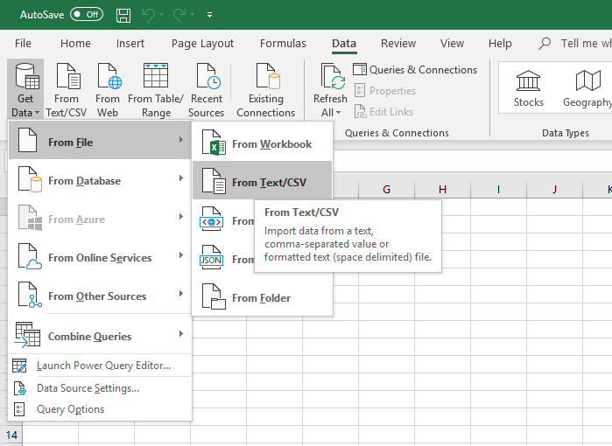From the Data tab, select “Get data”, “From File”, “From Text/CSV”
3. Import Data will open, select the file you want to import
4. Another window will open, in the “File Origin” dropdown select “65001: Unicode (UTF-8). If you don’t want to modify anything else, click on “Load” button.

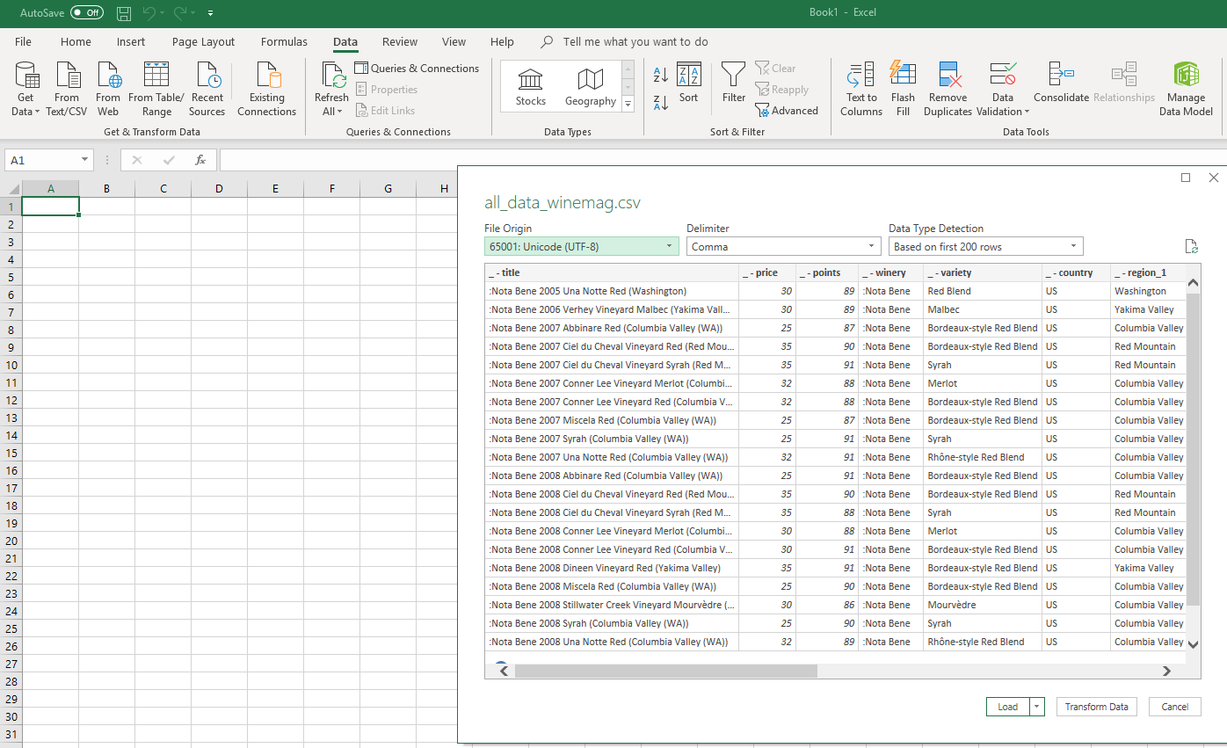

1. When you’re done be sure to save as “CSV UTF-8 (Comma delimited) (\*.csv)”

